RuleAdminScreen

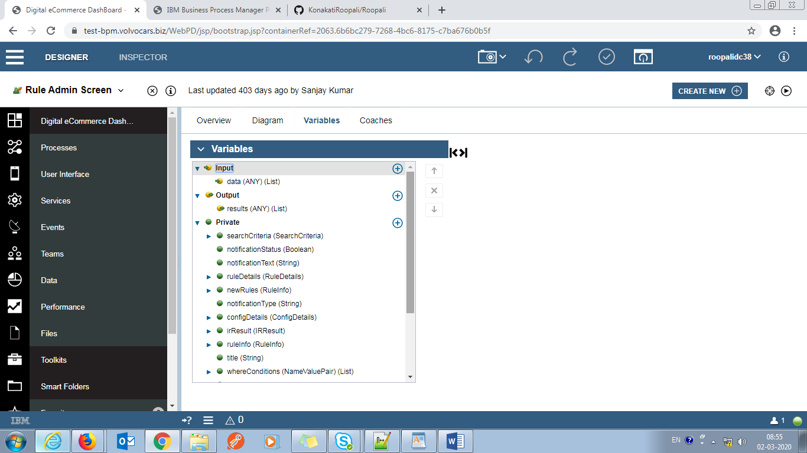

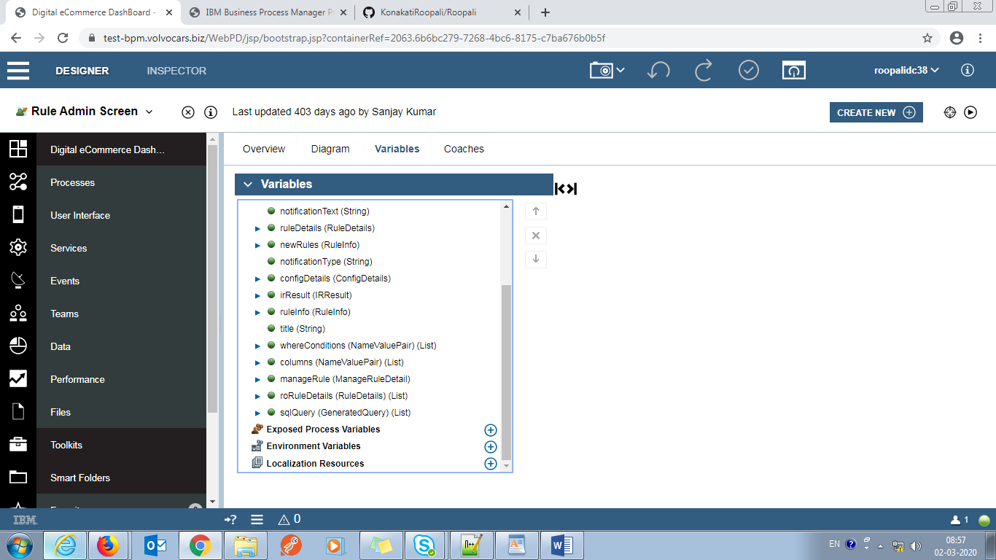

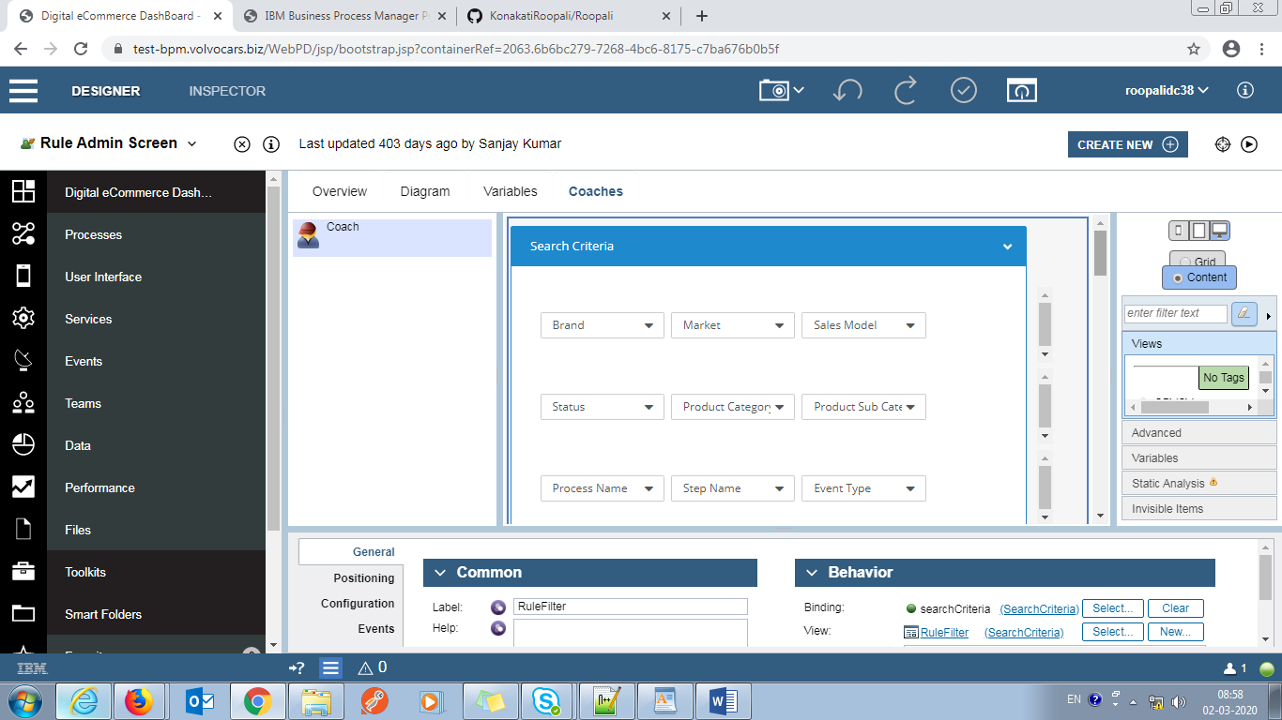

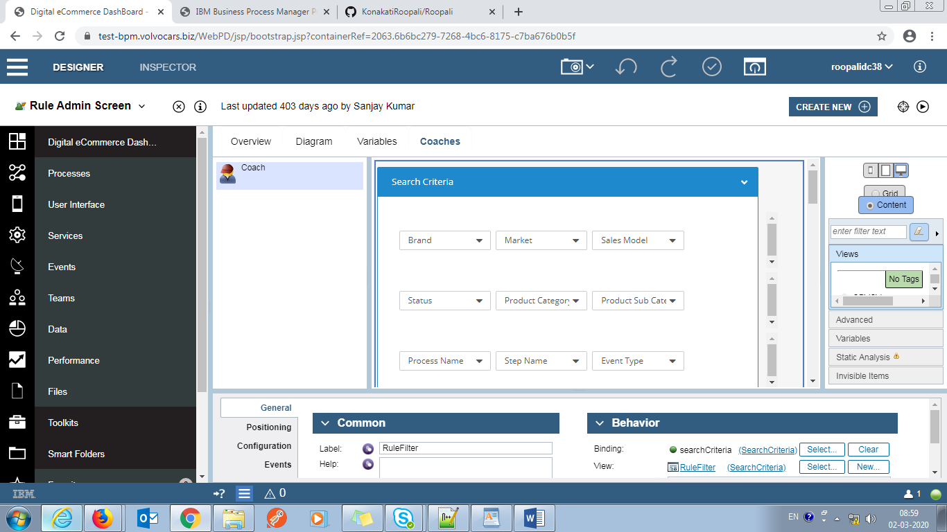

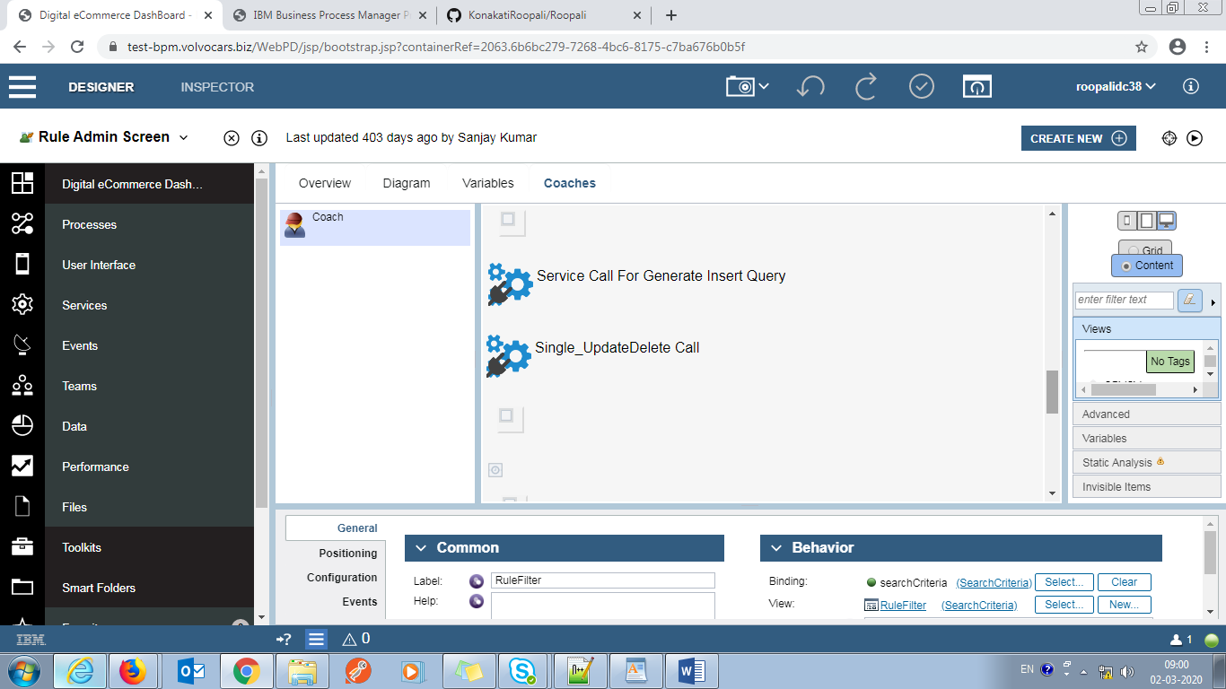

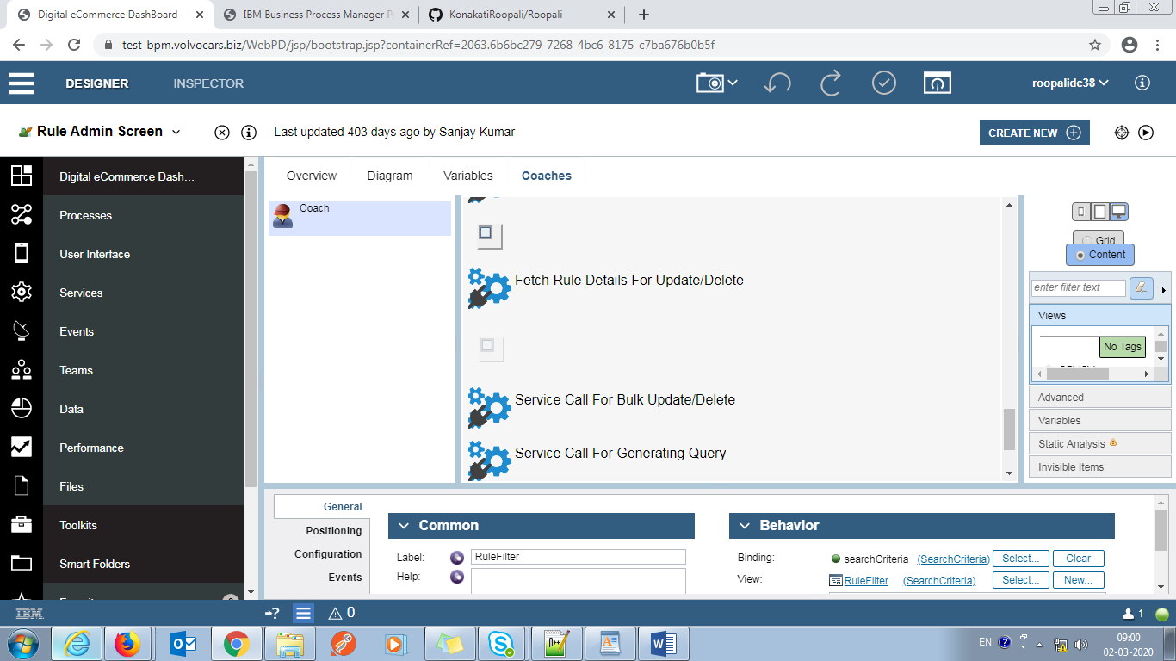

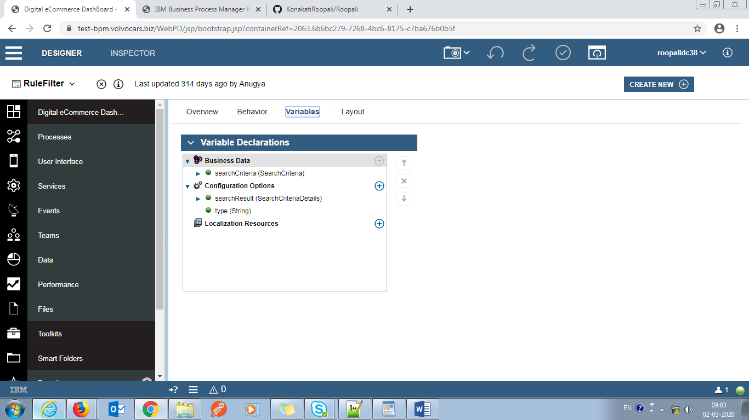

Javascript:

this.validateControl=function(control,text){

//console.log(control.getData().length+","+text);

control.setValid(control.getData()!=null && control.getData()!='null' && control.getData().length>0,text);

return control.isValid();

}

this.validateComponent=function(){

var result=true;

if(((this.validateControl(this.ui.get('s_brand'),"Select Brand"))==true

|| (result=this.validateControl(this.ui.get('s_market'),"Select Market"))==true

|| (result=this.validateControl(this.ui.get('s_salesModel'),"Select Sales Model"))==true

|| (result=this.validateControl(this.ui.get('s_status'),"Select Status"))==true

|| (result=this.validateControl(this.ui.get('s_productCategory'),"Select Product Category"))==true)

&& (result=this.validateControl(this.ui.get('s_status'),"Select Status"))==true){

this.ui.get('s_brand').setValid(true);

this.ui.get('s_market').setValid(true);

this.ui.get('s_salesModel').setValid(true);

this.ui.get('s_productCategory').setValid(true);

return true;

}else{

return false;

}

}

this.loadSingleSelect=function(data,s_control,d_control){

d_control.clearItems();

if(s_control && data){

if(data.items){

d_control.appendItem(null,"--SELECT--");

for(var i=0;i<data.items.length;i++){

d_control.appendItem(data.items[i].name,data.items[i].value);

}

}

}

}

this.loadData = function(){

var data=this.ui.get('sc_getSearchDetails').getData();

if(data){

this.loadSingleSelect(data.brand,this.ui.get('sc_getSearchDetails'),this.ui.get('s_brand'));

this.loadSingleSelect(data.market,this.ui.get('sc_getSearchDetails'),this.ui.get('s_market'));

this.loadSingleSelect(data.productCategory,this.ui.get('sc_getSearchDetails'),this.ui.get('s_productCategory'));

this.loadSingleSelect(data.productSubCategory,this.ui.get('sc_getSearchDetails'),this.ui.get('s_prodSubCategory'));

this.loadSingleSelect(data.salesModel,this.ui.get('sc_getSearchDetails'),this.ui.get('s_salesModel'));

this.loadSingleSelect(data.processName,this.ui.get('sc_getSearchDetails'),this.ui.get('s_processName'));

this.loadSingleSelect(data.stepName,this.ui.get('sc_getSearchDetails'),this.ui.get('s_stepName'));

this.loadSingleSelect(data.eventType,this.ui.get('sc_getSearchDetails'),this.ui.get('s_eventType'));

this.loadSingleSelect(data.status,this.ui.get('sc_getSearchDetails'),this.ui.get('s_status'));

}

}

this.reset=function(){

this.ui.get('s_brand').setData(null);

this.ui.get('s_market').setData(null);

this.ui.get('s_productCategory').setData(null);

this.ui.get('s_prodSubCategory').setData(null);

this.ui.get('s_salesModel').setData(null);

this.ui.get('s_processName').setData(null);

this.ui.get('s_stepName').setData(null);

this.ui.get('s_eventType').setData(null);

this.ui.get('s_status').setData(null);

this.ui.get('s_brand').setValid(true);

this.ui.get('s_market').setValid(true);

this.ui.get('s_salesModel').setValid(true);

this.ui.get('s_status').setValid(true);

this.ui.get('s_productCategory').setValid(true);

this.ui.get('sc_getSearchDetails').execute();

}

**Rule Details:**

**Service Data Table:**

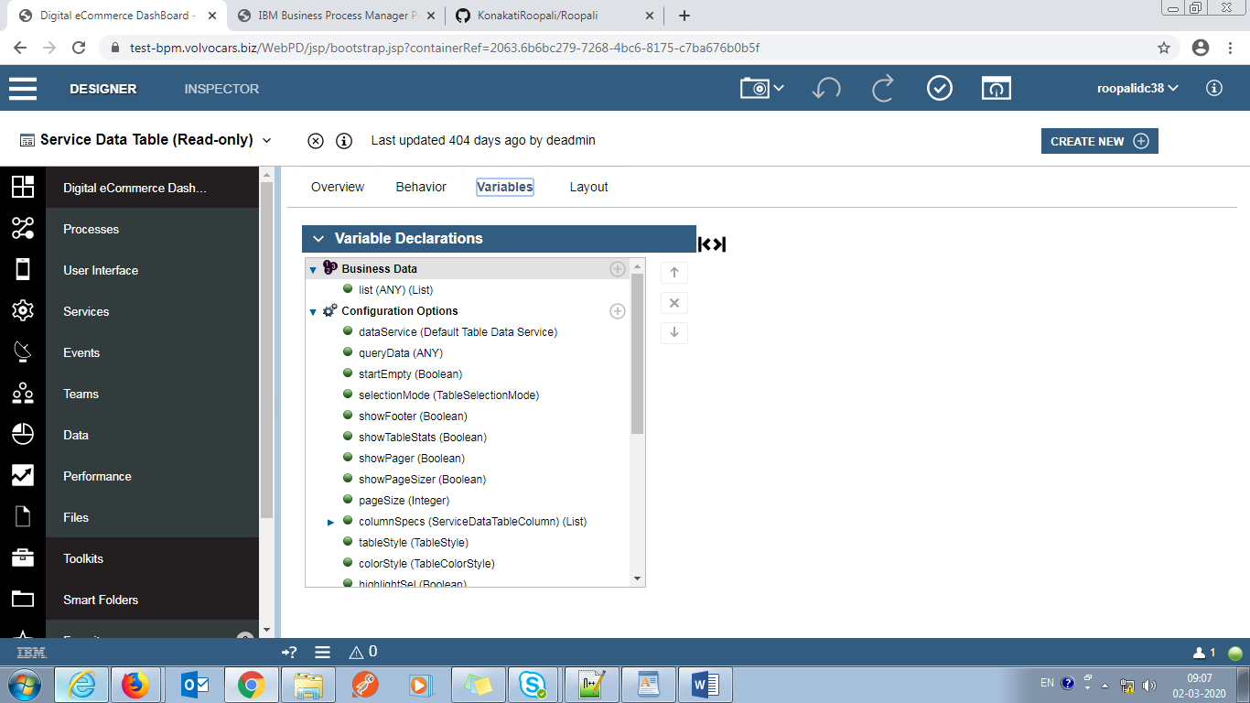

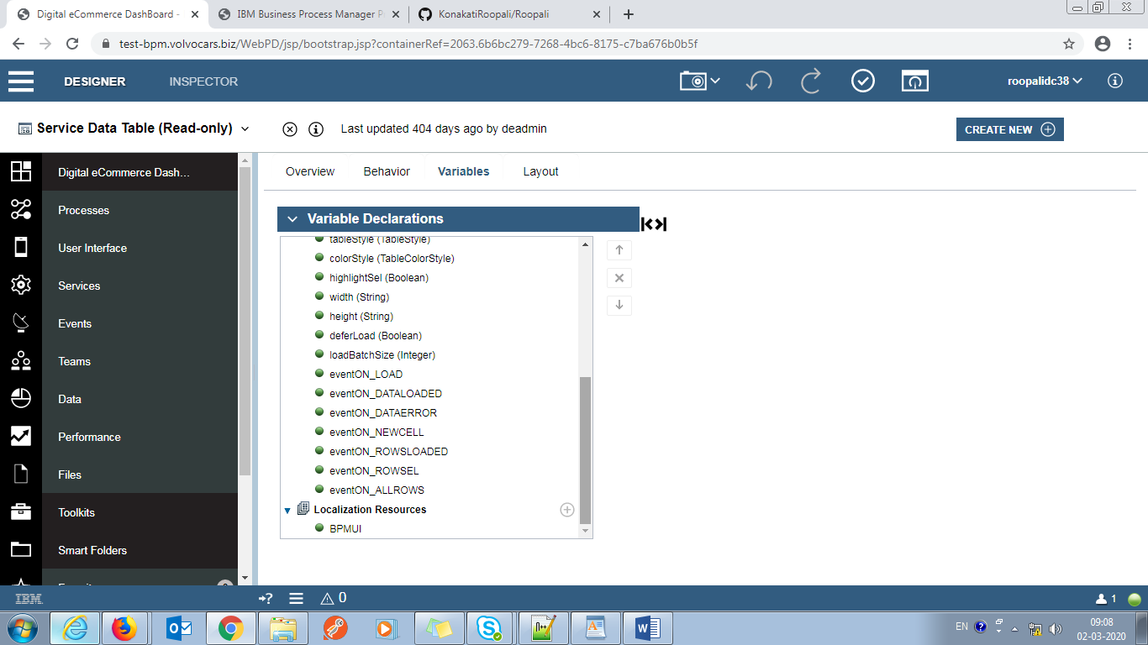

Service Call for save :

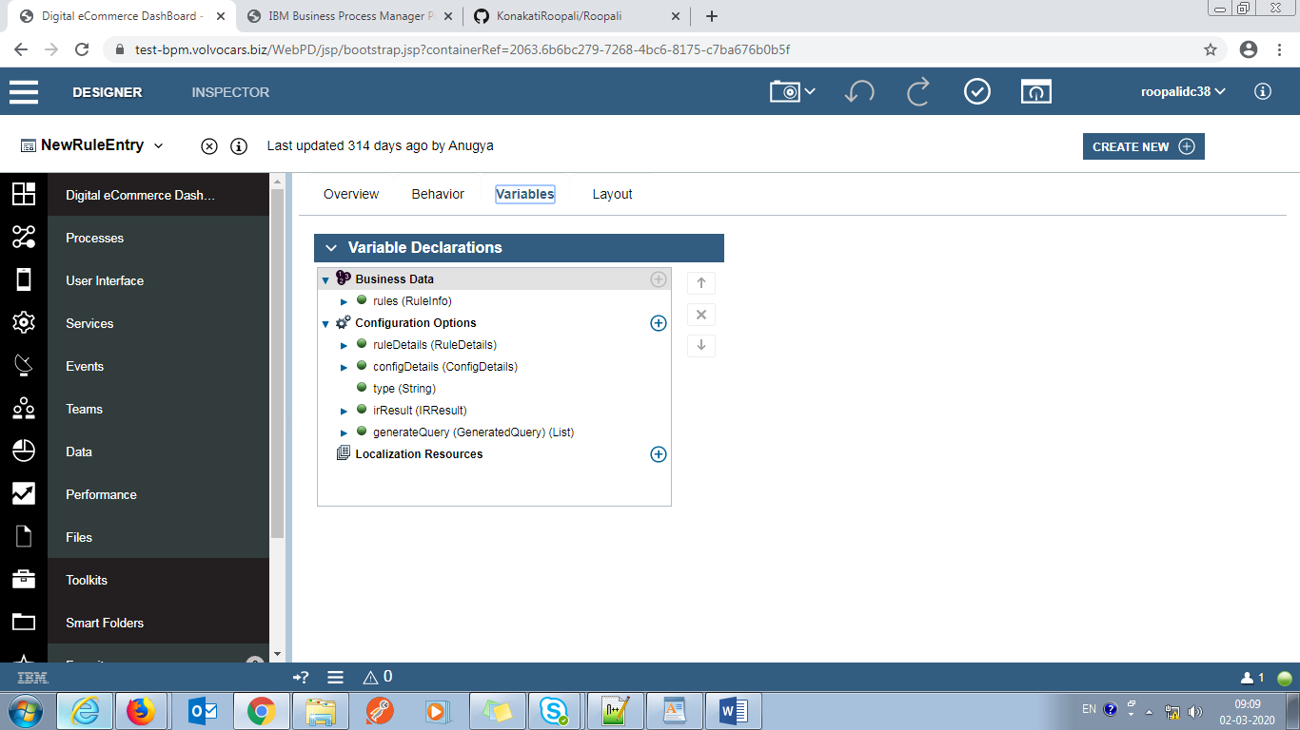

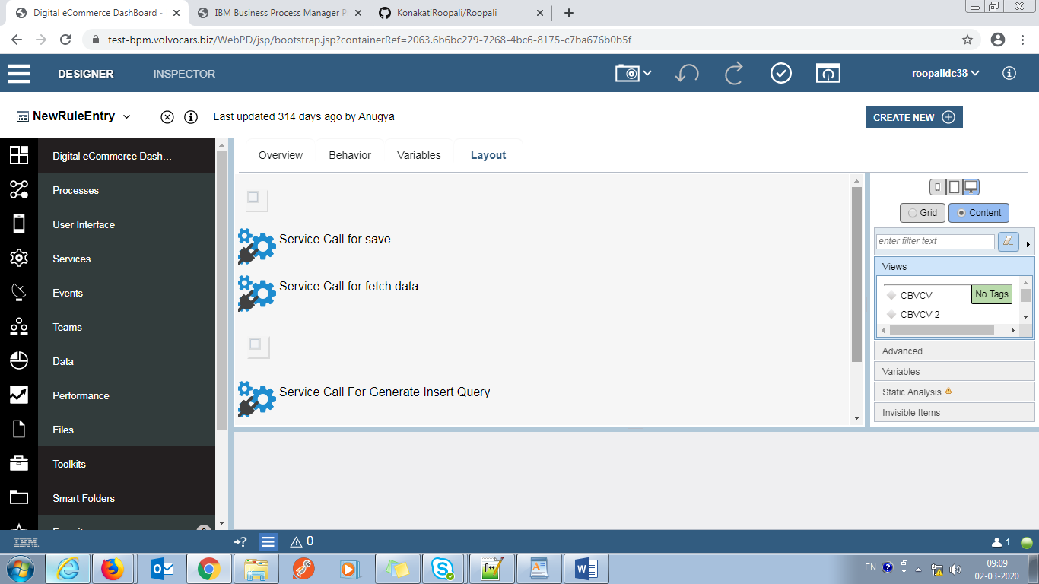

var view=this;

this.showScreen= function(){

this.ui.get('m_newScreen').setVisible(true);

}

this.showNotification= function(){

this.ui.get('m_newScreen').setVisible(true);

}

this.closeScreen = function(){

this.ui.get('m_newScreen').setVisible(false);

}

this.loadSaveNotification=function(){

this.ui.get('m_newScreen').setVisible(false);

this.ui.get('s_saveRule').execute();

}

this.resetView=function(){

this.context.binding.get("value").set("ruleDetails", []);

}

this.setConfiguration=function(data,index){

console.log('INDEX '+index);

this.ui.get('Table1').removeRecord(index);

this.ui.get('Table1').appendElement(data);

}

this.previewResult=function(){

this.closeScreen();

this.ui.get('PreviewResult').showScreen();

}

generateInsertQuery=function(){

var data =view.context.binding.get("value");

view.ui.get('s_generateInsertQuery').execute(data);

}

generateReports=function(queryData){

view.context.options.generateQuery.set("value", queryData);

view.ui.get('Data_Export1').click();

}

**On Change**

this.context.options.ruleDetails.set("value", {})

this.context.options.type.set("value", 'SAVE')

view_Config=function(data){

console.log('INDEX '+page.ui.get('/NewRuleEntry1/Table1').getRecordIndex(data,true));

page.ui.get('/NewRuleEntry1/DisplayColumnDetails12').setRuleDetails(data,page.ui.get('/NewRuleEntry1/Table1').getRecordIndex(data,true));

page.ui.get('/NewRuleEntry1/DisplayColumnDetails12').showModal();

}

**Dcom Market Configuration :**

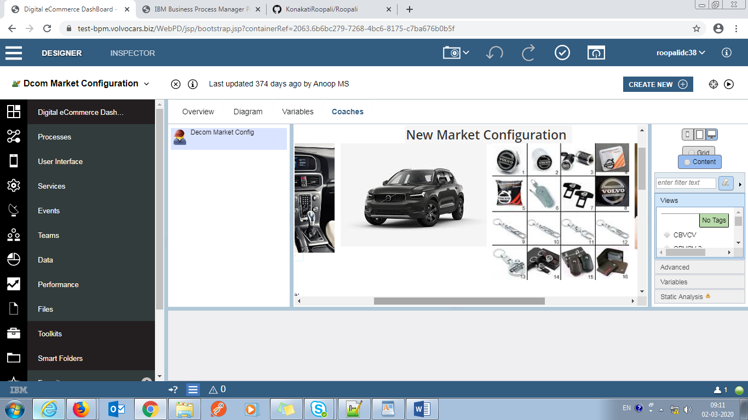

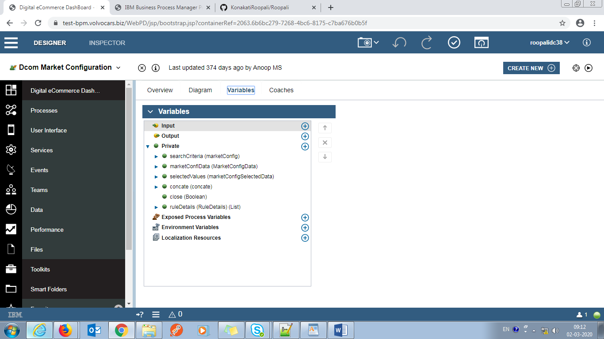

JavaScript:

var view= this;

getDropDown =function(marketConfigdata)

{

view.context.options.marketConfig.set("value",marketConfigdata);

//console.log(view.context.options.marketConfig.get("value").get("deliveryMode"))

}

this.validateControle = function(control,text)

{

control.setValid(control.getData()!=null && control.getData()!='null' && control.getData().length>0, text);

return control.isValid();

}

showModel = function()

{

var result = true;

var marketData = view.ui.get("marketId");

var productCat =view.ui.get("ProductCategory");

var regretPeriod = view.ui.get('regretPeriod');

var regretPeriod1 = view.ui.get('regretPeriod1');

if(marketData.getData()!=null && marketData.getData()!='null'){

if(marketData.getData().length==0){

marketData.setValid(marketData.getText().length >0,'Enter Market Id');

}

else{

marketData.setValid(true);

}

}

else{

//alert("inside else")

marketData.setValid(false,'Enter Market Id');

}

if(productCat.getSelectedIndex()==-1){

if(productCat.getData()!=null && productCat.getData()!='null'){

//alert("inside");

productCat.setValid(productCat.getData().length>0, 'Select Product Category');

}

else{

//alert("inside else")

productCat.setValid(false,'Select Product Category');

}

}

else{

productCat.setValid(true);

}

var brand =view.ui.get("brand");

if(brand.getSelectedIndex()==-1){

if(brand.getData()!=null && brand.getData()!='null' ){

brand.setValid(brand.getData().length>0, 'Select Brand');

}

else{

//alert("inside else")

brand.setValid(false,'Select Brand');

}

}

else{

brand.setValid(true);

}

if(regretPeriod.getData()<0){

regretPeriod.setValid(regretPeriod.getData().length>0, "Negative values are not allowed.");

}

if(regretPeriod1.getData()<0){

regretPeriod1.setValid(regretPeriod.getData().length>0, "Negative values are not allowed.");

}

if(productCat.getSelectedItem()!= null ||productCat.getSelectedItem()!= undefined) {

if(productCat.getSelectedItem().name=='ACC'||productCat.getSelectedItem()=='ACC'){

var deliveryMode =view.ui.get("deliveryMode");

if(deliveryMode.getSelectedIndex()==-1){

if(deliveryMode.getData()!=null && deliveryMode.getData()!='null'){

deliveryMode.setValid(deliveryMode.getData().length>0, 'Select Delivery Mode');

}

}

else{

deliveryMode.setValid(true);

}

}

}

if ( marketData.isValid()==true&&productCat.isValid()==true&& brand.isValid()==true&&regretPeriod.isValid()==true&&regretPeriod1.isValid())

{

// alert("If step");

var n1 = view.ui.get("Modal_Section1")

n1.context.options._metadata.visibility.set("value","EDITABLE");

var n2 = view.ui.get("selectReq1");

var n3 = view.ui.get("selectReq2");

var n4 = view.ui.get("selectReq3");

var n5 = view.ui.get("hori1");

var n6= view.ui.get("customerCheck");

//n6.context.options._metadata.visibility.set("value", "NONE");

//alert(productCat.getSelectedItem().name);

if(productCat.getSelectedItem().name=='CAR'||productCat.getSelectedItem()=='CAR')

{

if(brand.getSelectedItem().name=='POL'||brand.getSelectedItem()=='POL'){

//alert("inside else"+brand.getSelectedItem().name);

n2.context.options._metadata.visibility.set("value","EDITABLE");

n3.context.options._metadata.visibility.set("value","NONE");

n4.context.options._metadata.visibility.set("value","NONE");

n6.context.options._metadata.visibility.set("value", "EDITABLE");

}

else{

//alert("inside else"+brand.getSelectedItem().name);

n2.context.options._metadata.visibility.set("value","EDITABLE");

n3.context.options._metadata.visibility.set("value","NONE");

n4.context.options._metadata.visibility.set("value","NONE");

n6.context.options._metadata.visibility.set("value", "NONE");

}

}

if(productCat.getSelectedItem().name=='ACC'||productCat.getSelectedItem()=='ACC')

{

n3.context.options._metadata.visibility.set("value","EDITABLE");

n2.context.options._metadata.visibility.set("value","NONE");

n4.context.options._metadata.visibility.set("value","NONE");

}

if(productCat.getSelectedItem().name=='SERV'||productCat.getSelectedItem()=='SERV')

{

n3.context.options._metadata.visibility.set("value","NONE");

n2.context.options._metadata.visibility.set("value","NONE");

n4.context.options._metadata.visibility.set("value","EDITABLE");

}

}

}

setReset = function()

{

view.ui.get('ProductCategory').setSelectedItem(null);

view.ui.get('ProductCategory').setValid(true);

view.ui.get('brand').setSelectedItem(null);

view.ui.get('brand').setValid(true);

view.ui.get("marketId").setData(null);

view.ui.get("marketId").setValid(true);

view.ui.get("deliveryMode").setSelectedItem(null);

view.ui.get("deliveryMode").setValid(true);

view.ui.get("marketDescrip").setData(null);

view.ui.get("marketDescrip").setValid(true);

view.ui.get("regretPeriod").setData(null);

view.ui.get("regretPeriod").setValid(true);

var deliveryMode = view.ui.get('deliveryMode');

deliveryMode.context.options._metadata.visibility.set("value", "NONE");

}

//resetFunctionality=function()

//{

//view.context.options.marketConfiData.set("value", null)

//}

insertData =function()

{

var validData=true;

//alert('test');

var checkbox1 = view.ui.get("Checkbox66");

//alert(checkbox1);

if(checkbox1.getData()==true){

var sla= view.ui.get("Text5");

// sla.setValid(sla.getData().length>0, "Enter sla value");

//alert(sla.getData());

if(sla.getData()<0) {

// alert("inside if");

sla.setValid(sla.getData().length>0, "Negative values are not allowed");

validData=false;

}

}

var checkbox2 = view.ui.get("Checkbox10");

if(checkbox2.getData()==true){

var sla1= view.ui.get("Text9");

//sla1.setValid(sla1.getData().length>0, "Enter sla value");

if(sla1.getData()<0) {

sla1.setValid(sla1.getData().length>0, "Negative values are not allowed.");

validData=false;

}

//validData=false;

}

var checkbox3 = view.ui.get("Checkbox70");

//alert(checkbox1);

if(checkbox3.getData()==true){

var sla3= view.ui.get("Text15");

// sla3.setValid(sla.getData().length>0, "Enter sla value");

if(sla3.getData()<0) {

sla3.setValid(sla.getData().length>0, "Negative values are not allowed.");

validData=false;

}

//validData=false;

}

if(validData==true)

{

console.log('insert data: ' +view.context.options.marketConfiData.get("value").get("crmData").get("enable"))

view.context.options.concate.get("value").set("marketConfiData", view.context.options.marketConfiData.get("value"))

view.context.options.concate.get("value").set("marketConfigSelectedData", view.context.options.selectedValues.get("value"))

console.log(JSON.stringify(view.context.options.concate));

view.ui.get("insertDatainto").execute();

var n1 = view.ui.get("Modal_Section1");

var deliveryMode = view.ui.get('deliveryMode');

n1.context.options._metadata.visibility.set("value","NONE");

}

else{

view.ui.get("Horizontal_Layout49").context.options._metadata.visibility.set("value","EDITABLE");

}

}

setVisibleDM = function(){

var image = view.ui.get('image');

var carImage = view.ui.get('carImage');

var accImage = view.ui.get('accImage');

var vocImage = view.ui.get('vocImage');

var productCategory = view.ui.get("ProductCategory");

var deliveryMode = view.ui.get('deliveryMode');

var regretPeriod = view.ui.get('regretPeriod');

var regretPeriod1 = view.ui.get('regretPeriod1');

var Section7 = view.ui.get("Section7");

view.ui.get("regretPeriod").setData(null);

if(productCategory.getSelectedItem()!=null){

if(productCategory.getSelectedItem().name=="ACC"||productCategory.getSelectedItem()=="ACC"){

deliveryMode.context.options._metadata.visibility.set("value", "EDITABLE");

regretPeriod.context.options._metadata.visibility.set("value", "EDITABLE");

regretPeriod1.context.options._metadata.visibility.set("value", "NONE");

Section7.context.options._metadata.visibility.set("value", "EDITABLE");

}

else{

deliveryMode.context.options._metadata.visibility.set("value", "NONE");

regretPeriod.context.options._metadata.visibility.set("value", "NONE");

regretPeriod1.context.options._metadata.visibility.set("value", "NONE");

Section7.context.options._metadata.visibility.set("value", "NONE");

}

if(productCategory.getSelectedItem().name=="CAR"||productCategory.getSelectedItem()=="CAR"){

regretPeriod1.context.options._metadata.visibility.set("value", "EDITABLE");

Section7.context.options._metadata.visibility.set("value", "NONE");

}

if(productCategory.getSelectedItem().name=="ACC"||productCategory.getSelectedItem()=="ACC"){

accImage.context.options._metadata.visibility.set("value", "EDITABLE");

carImage.context.options._metadata.visibility.set("value", "NONE");

vocImage.context.options._metadata.visibility.set("value", "NONE");

image.context.options._metadata.visibility.set("value", "NONE");

}

else if(productCategory.getSelectedItem().name=="SERV"||productCategory.getSelectedItem()=="SERV"){

vocImage.context.options._metadata.visibility.set("value", "EDITABLE");

carImage.context.options._metadata.visibility.set("value", "NONE");

accImage.context.options._metadata.visibility.set("value", "NONE");

image.context.options._metadata.visibility.set("value", "NONE");

}

else if(productCategory.getSelectedItem().name=="CAR"||productCategory.getSelectedItem()=="CAR"){

carImage.context.options._metadata.visibility.set("value", "EDITABLE");

accImage.context.options._metadata.visibility.set("value", "NONE");

vocImage.context.options._metadata.visibility.set("value", "NONE");

image.context.options._metadata.visibility.set("value", "NONE");

}

}

}

**On Load**

var view = this;

view.ui.get("getDropDownVal").execute();

var n1 = view.ui.get("Modal_Section1");

n1.context.options._metadata.visibility.set("value","NONE");

var image = view.ui.get('image');

var carImage = view.ui.get('carImage');

var accImage = view.ui.get('accImage');

var vocImage = view.ui.get('vocImage');

image.context.options._metadata.visibility.set("value", "EDITABLE");

accImage.context.options._metadata.visibility.set("value", "NONE");

vocImage.context.options._metadata.visibility.set("value", "NONE");

carImage.context.options._metadata.visibility.set("value", "NONE");

var regretPeriod = view.ui.get('regretPeriod');

var regretPeriod1 = view.ui.get('regretPeriod1');

regretPeriod.context.options._metadata.visibility.set("value", "NONE");

regretPeriod1.context.options._metadata.visibility.set("value", "NONE");

view.ui.get("Horizontal_Layout49").context.options._metadata.visibility.set("value","NONE");

view.ui.get("Modal_Section1").context.options._metadata.visibility.set("value", "NONE");

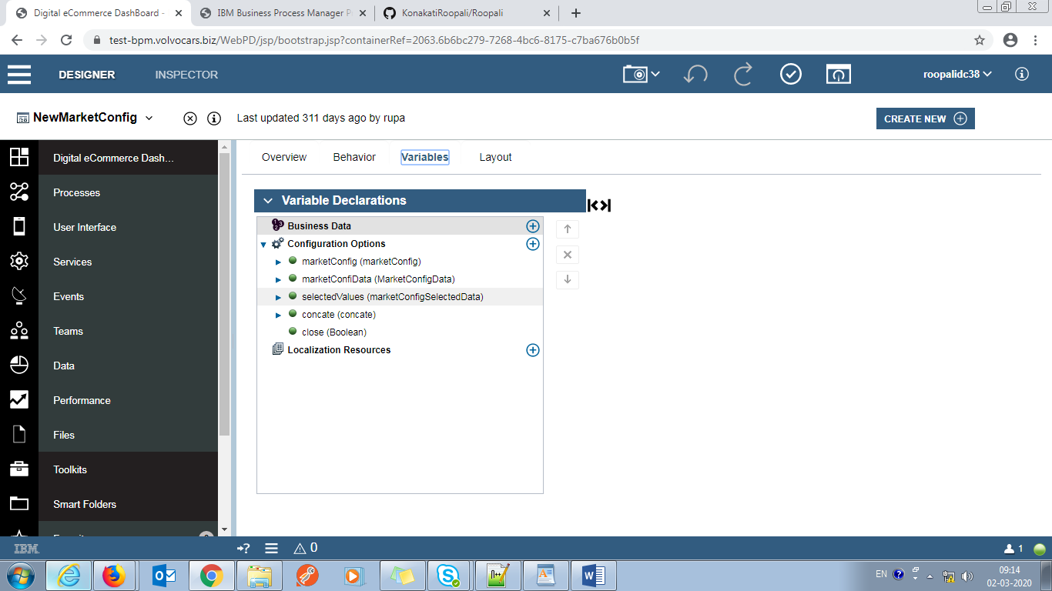

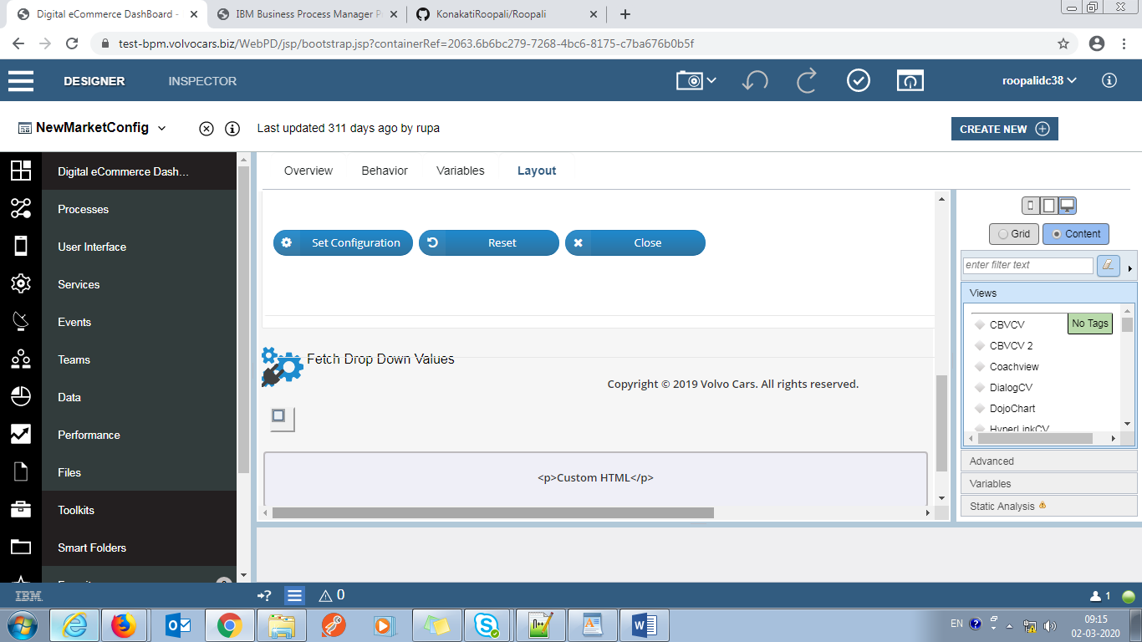

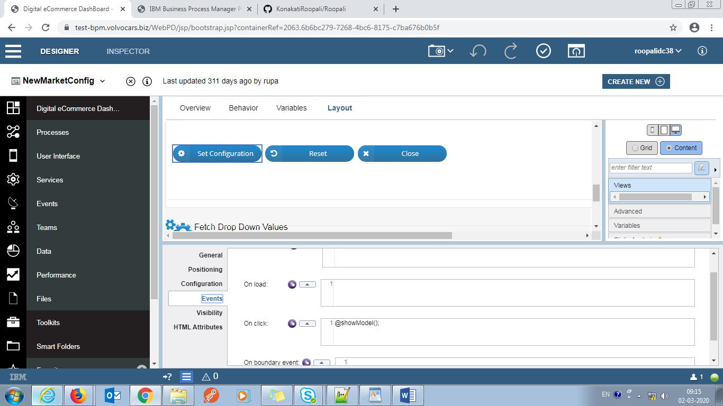

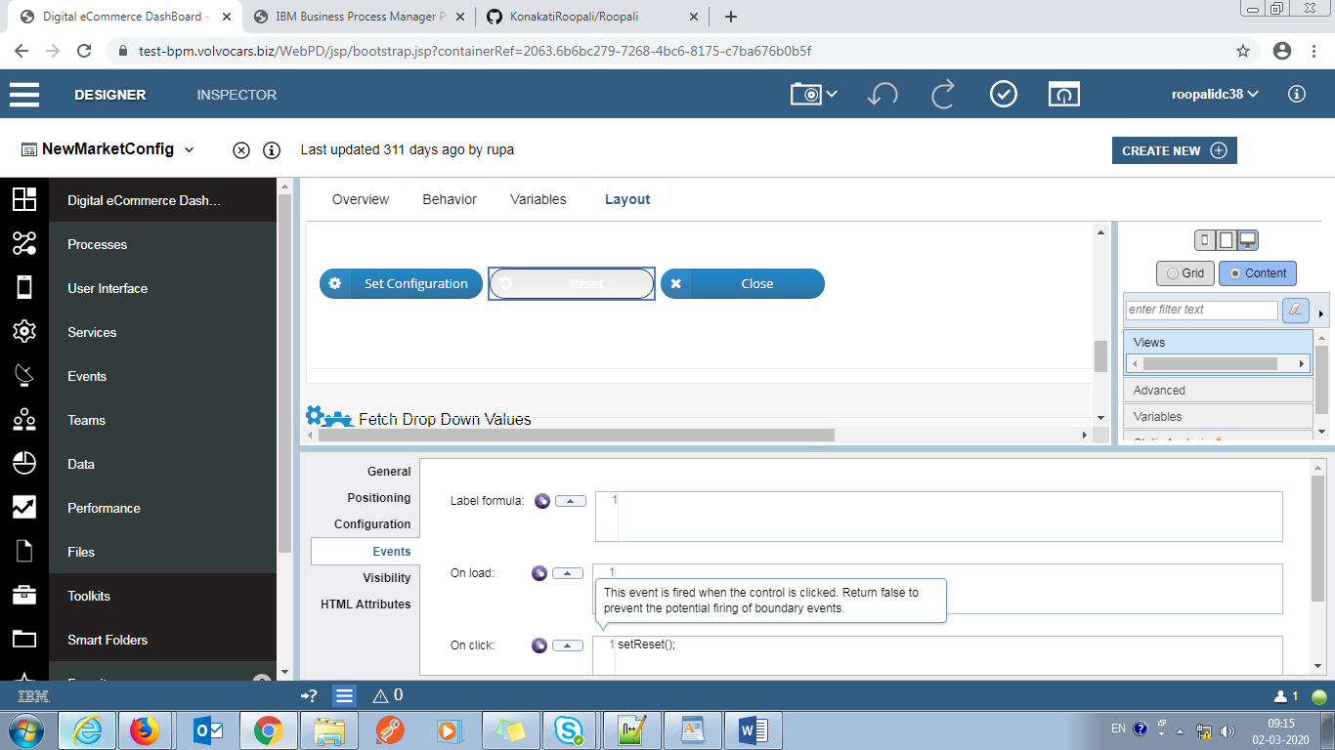

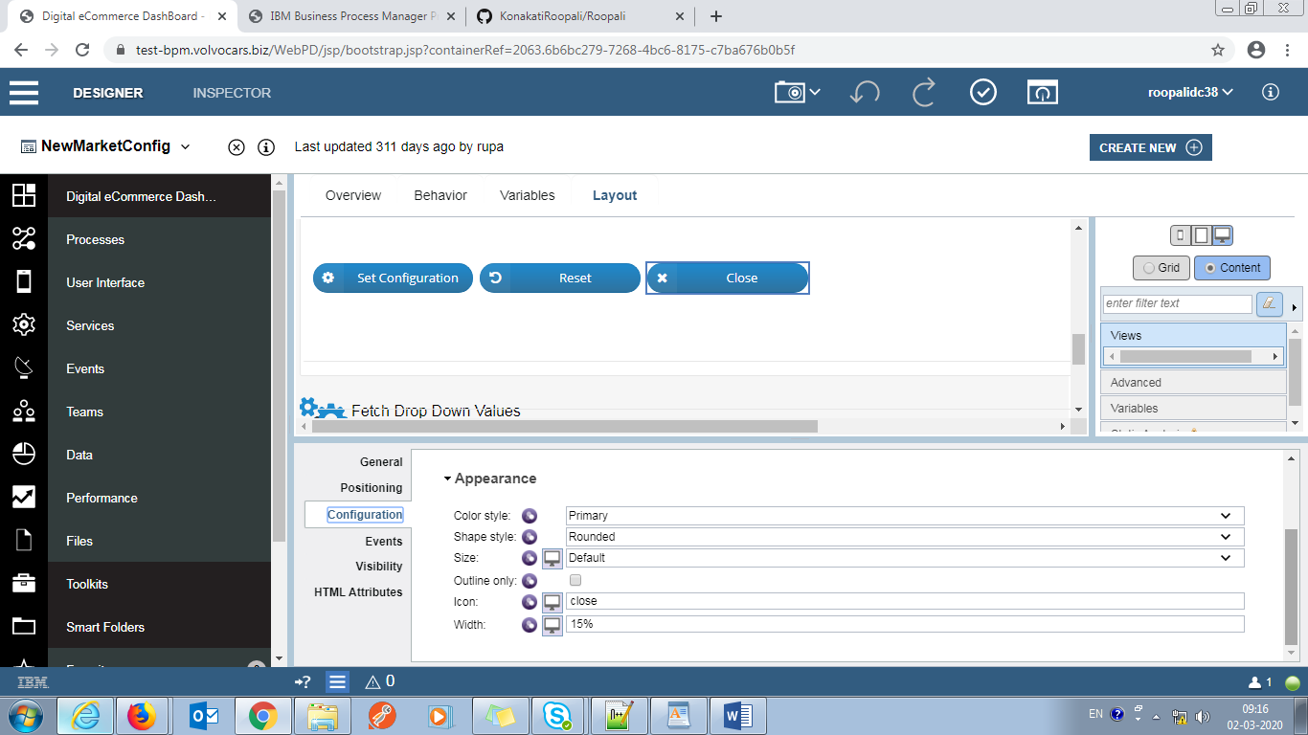

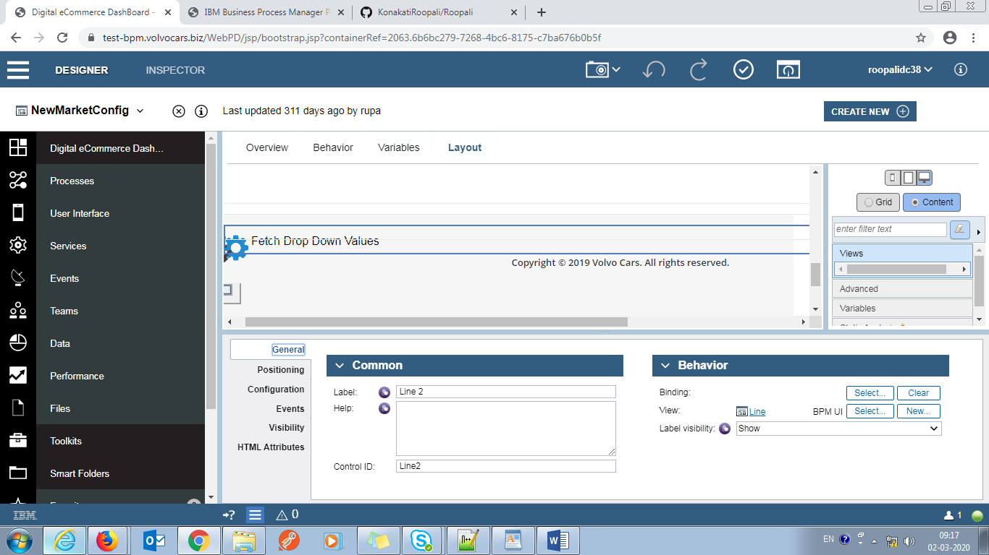

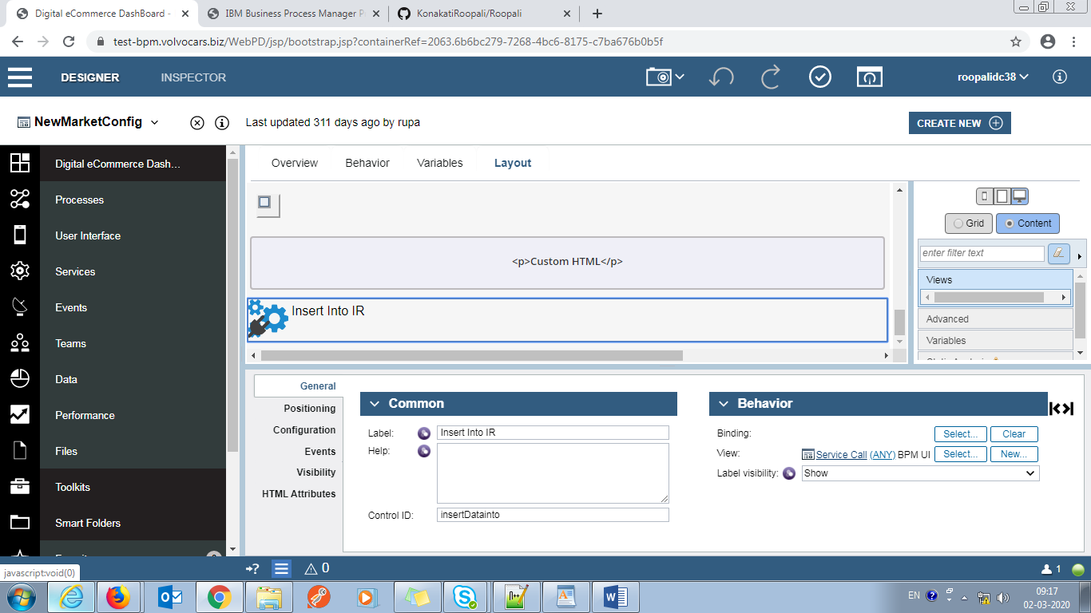

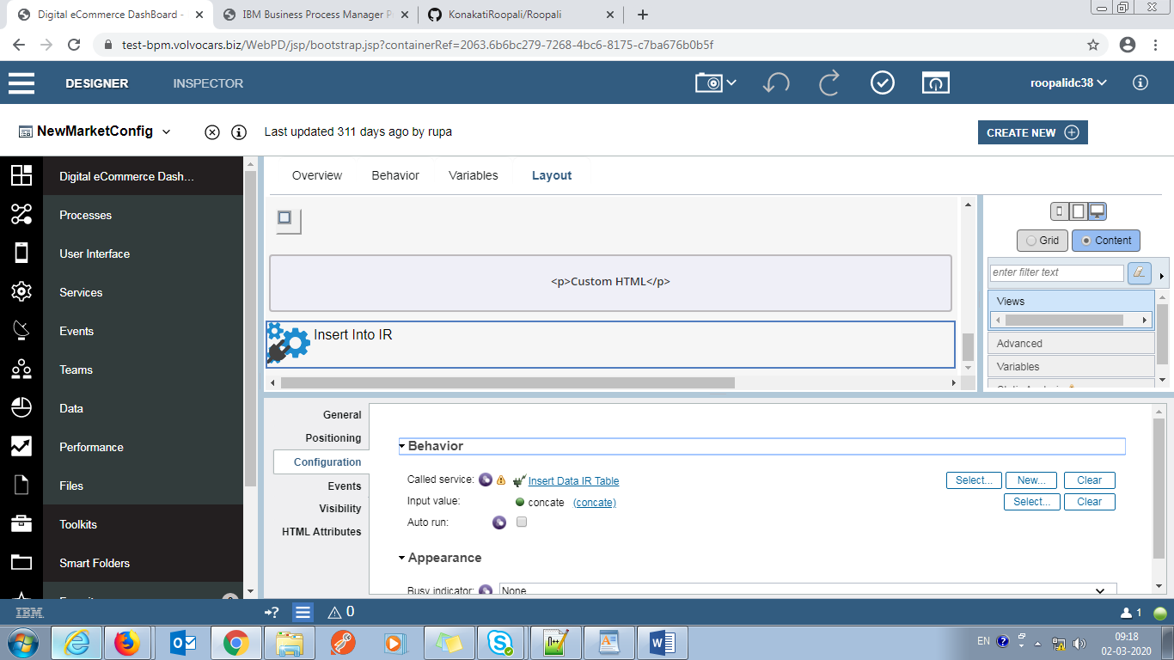

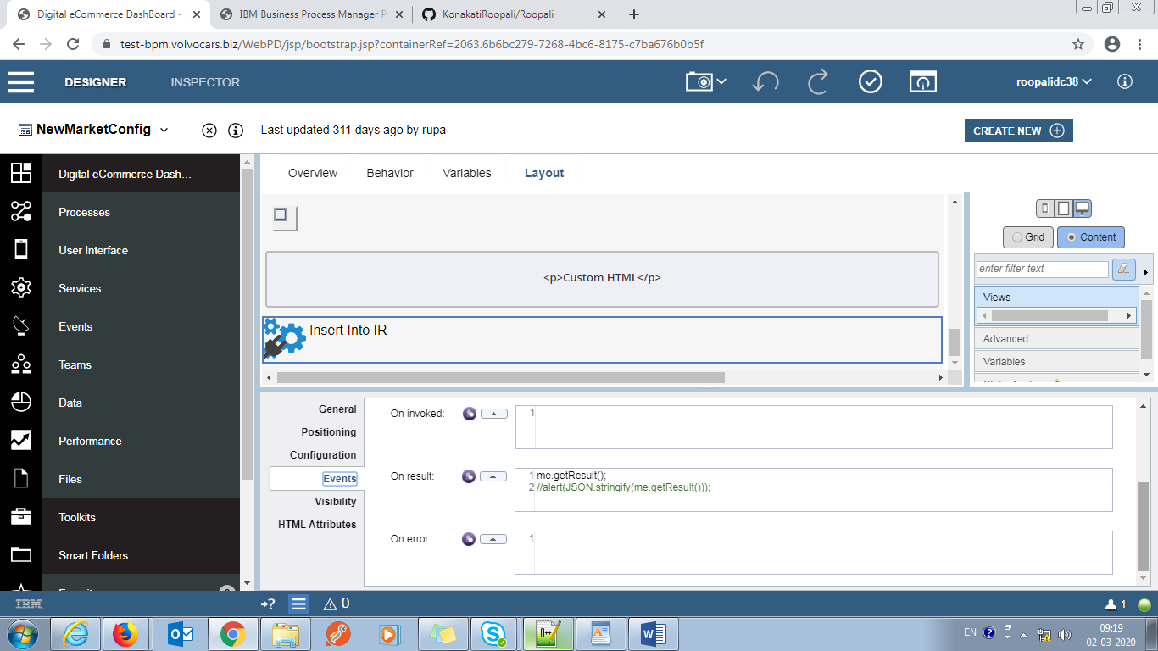

Regret Period:

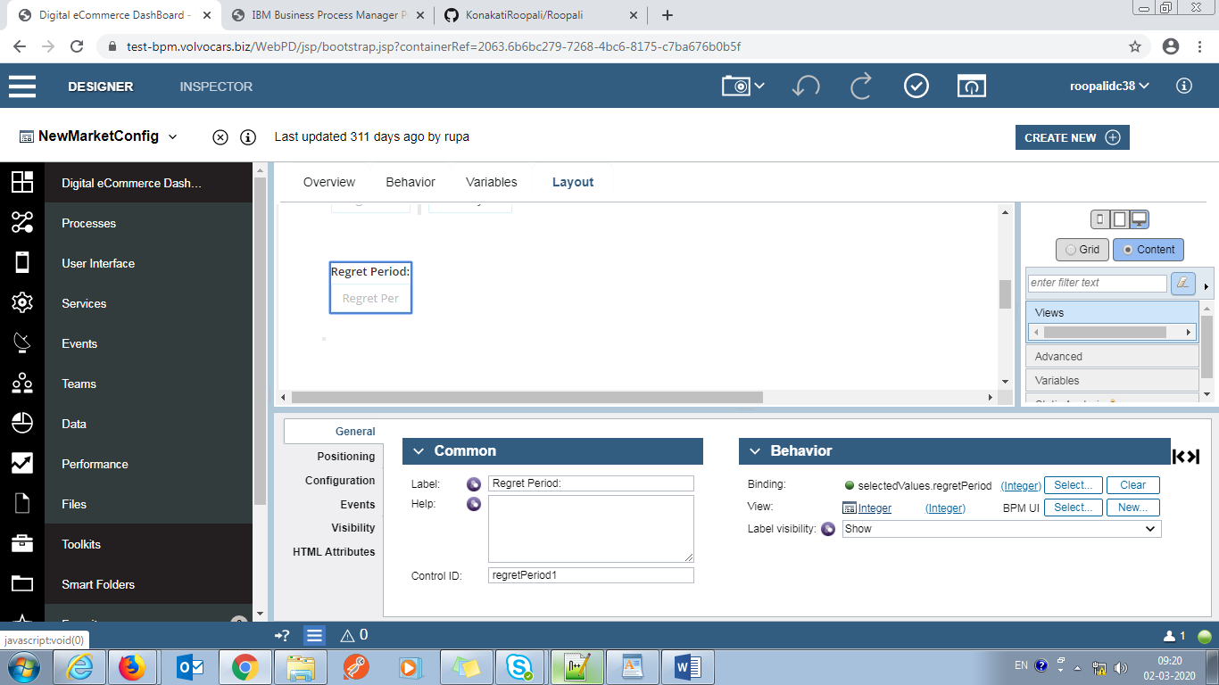

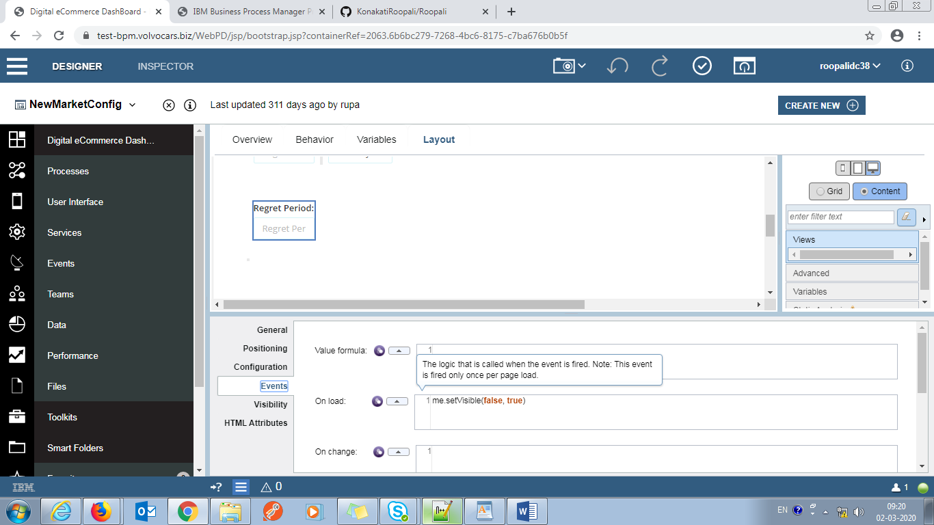

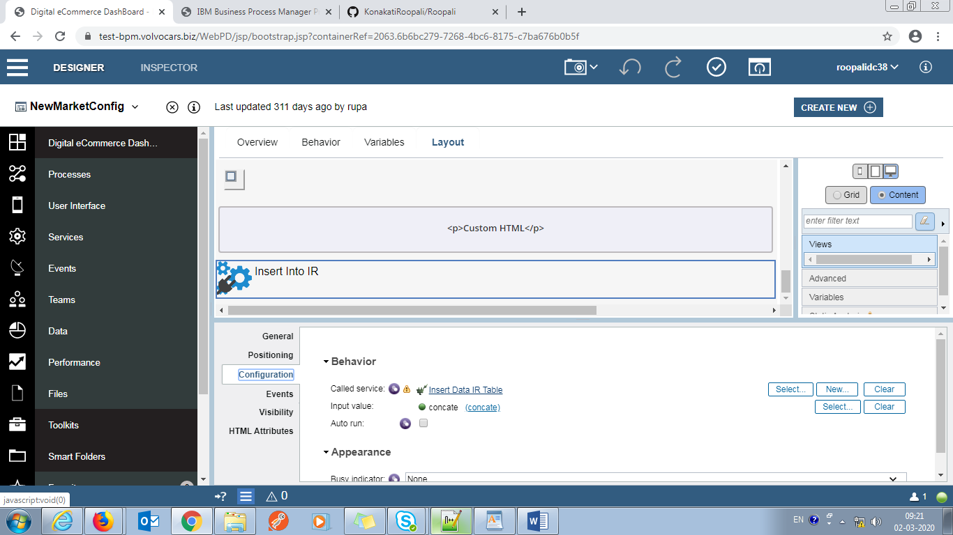

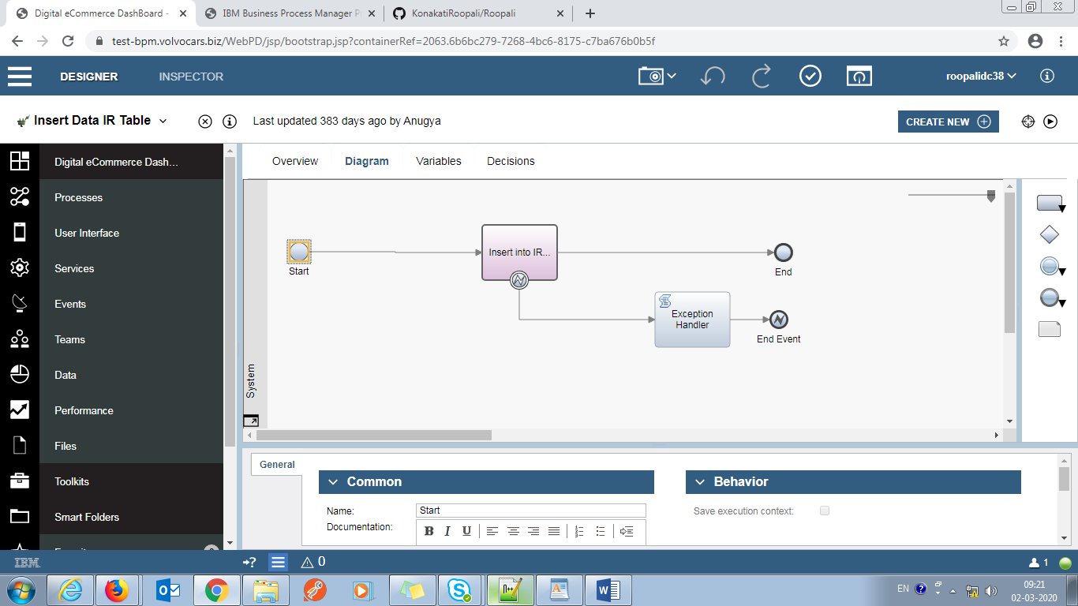

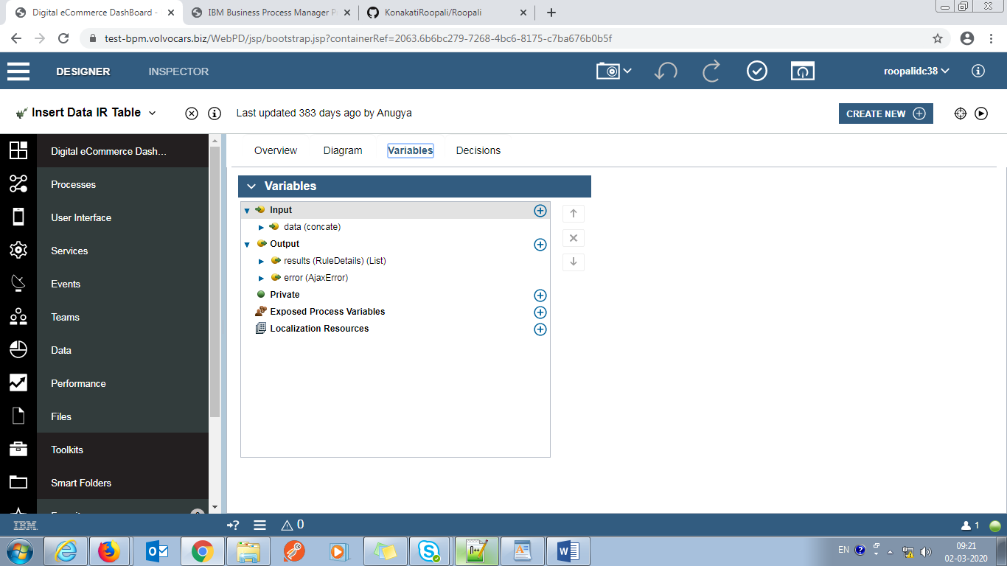

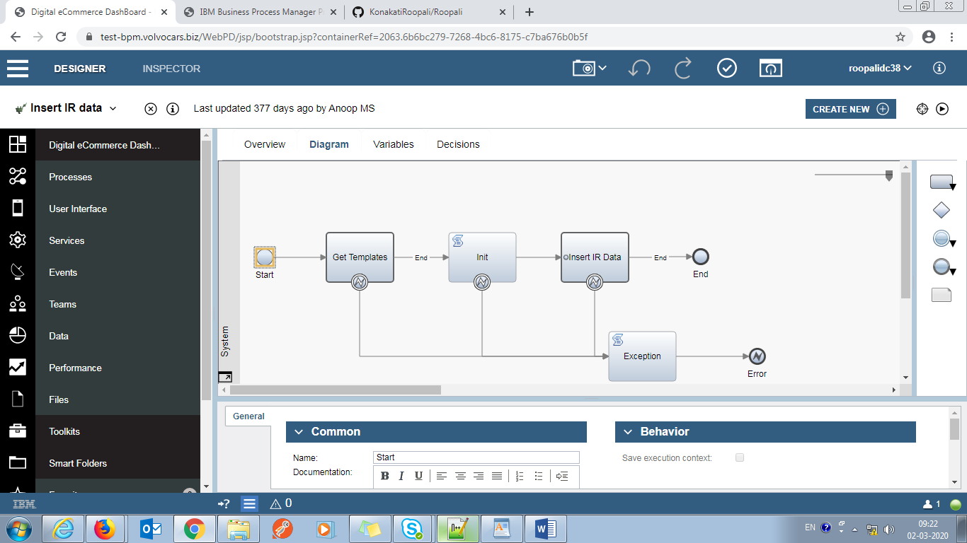

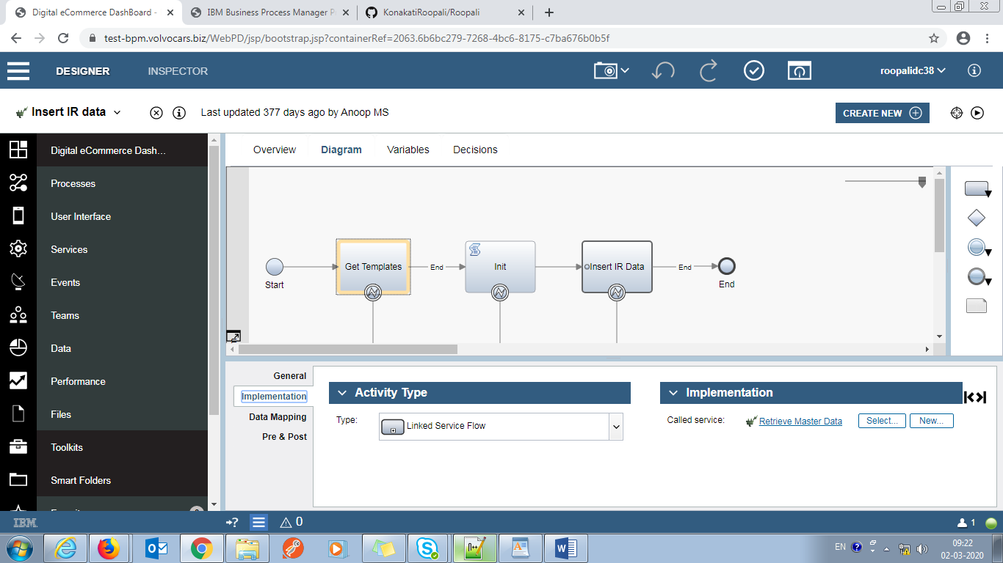

Retriever Master Data:

//tw.local.sql="SELECT [ATTRIBUTE_NAME] as name ,[ATTRIBUTE_VALUE] AS value FROM "+tw.env.schema_name+"[MASTER_DATA] where [ATTRIBUTE_TYPE]='"+tw.local.attrType+"'"

tw.local.sqlStatement= new tw.object.SQLStatement();

tw.local.sqlStatement.sql="SELECT [ATTRIBUTE_NAME] as name ,[ATTRIBUTE_VALUE] AS value FROM "+tw.env.schema_name+"[MASTER_DATA] where [ATTRIBUTE_TYPE]=?";

tw.local.sqlStatement.parameters=new tw.object.listOf.SQLParameter();

tw.local.sqlStatement.parameters.insertIntoList(tw.local.sqlStatement.parameters.listLength, params(tw.local.attrType,"varchar","IN"));

//insertIntoList(tw.local.sqlStatement.parameters.listLength, params("","varchar","IN"));

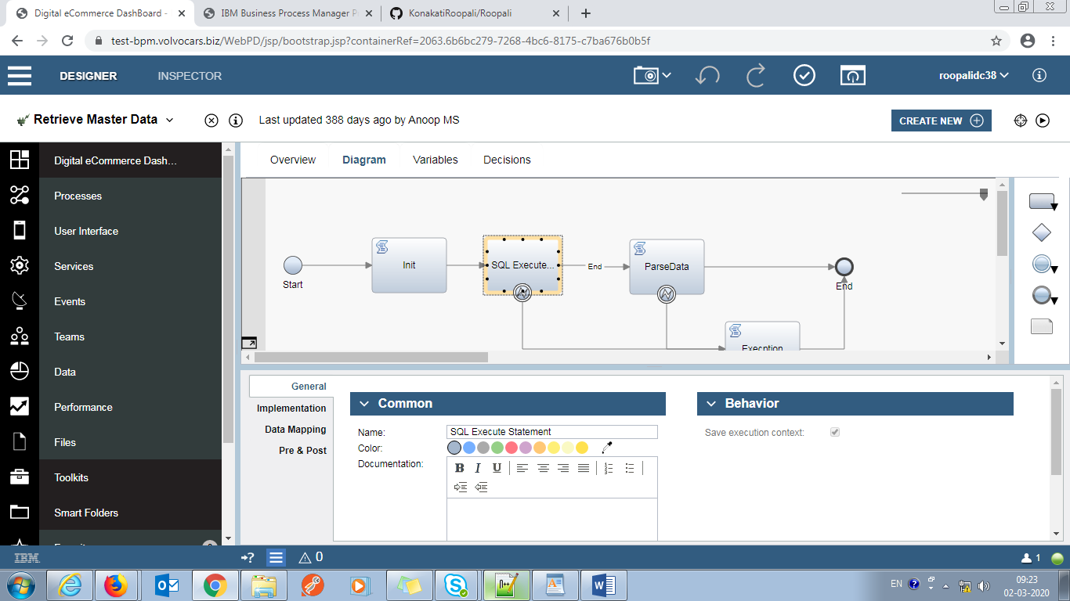

tw.local.result=new tw.object.Map();

for(var i=0;i<tw.local.listOfData.listLength;i++){

tw.local.result.put(tw.local.listOfData[i].name, tw.local.listOfData[i].value);

}

tw.local.sql=null;

**Exception:**

tw.local.error=tw.system.error;

